Loss Functions

what's the objective?? (find global minimal

Saturday, October 2, 2021

2:59 PM

for Repression loss-14-y,

of -What are they??

O -Where to we use them??

Q -Types of lossfunction??

convexifications .



MSE = EM

in (4.4 g

( y Lai, Lets the YET FICT, D)

YIIthen (I-A):



linear Regression





"ot's '45

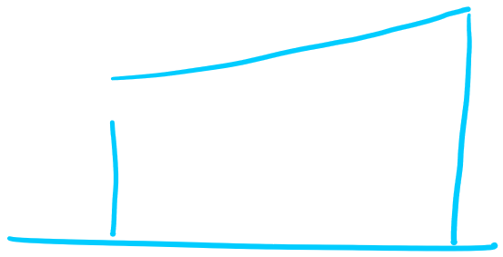

(





MAE = 17-7 .

↳(9=14-9, 4 A (1-1)=0 TII

."cx)710

sci',

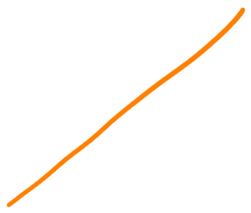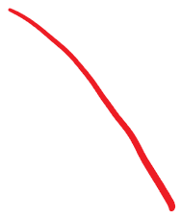

X,

XZ

!



fixie







II 'sin 5



.

classification problem H T ECOI] + a

ONMIE = (¥12 Let's the Her

•posttension 2 YTET = con)

214-4) MSE (4. item, .

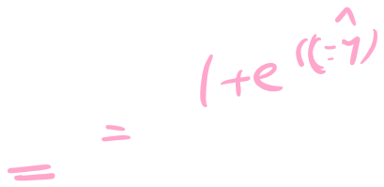

,



,







in's mum

As TC -00120) H 21011)

.

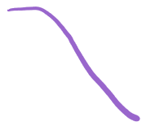

F , , l . \* . , ,

-4-5-2-10,234 &

ocross Entropy functions)

cost (7.19) = -logy-CI-y-Koger-igg) :

ology. 4 H ] ¢

toga-is 420



=



login')

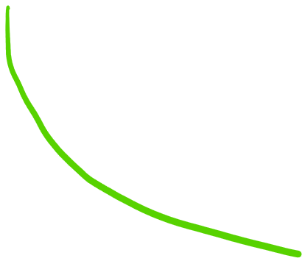

Log (y\*



it in's ! 7! In



#not.





=toglyn)



case\* y 42184=1

costly-y-tog(s)



=atog= toss)

O (minimum

cases 4=0 ( KEO

-Loga-i) costly-Tú-logit-y,



More error loss goes toward the



(tons.

minimum loss you

<https://towardsdatascience.com/why-not-mse-as-a-loss-function-for-logistic-regression-589816b5e03c>

<https://towardsdatascience.com/why-using-mean-squared-error-mse-cost-function-for-binary-classification-is-a-bad-idea-933089e90df7>